# Lecture 6

## 03/11/2021

Date part function

|  |
| --- |
| select DATE_PART('second', '2011-12-30 08:56:10'::timestamp - '2011-12-30 08:54:55'::timestamp); |

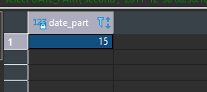

Input:

* Varchar denoting the increment
* Two timestamp values between which the difference needs to be calculated

Note: In the example above the timestamp cast is being done by the ‘::’ operator

Output

An integer number of seconds giving the difference between the two timestamp values.

**Grain:** denotes the lowest denominator of the date; what a single row should represent in the dataset

Example: What is the daily trip count?

-grain/row: daily observation count

What date column to use to establish the grain?

Tpep_pickup_datetime → date only

|  |
| --- |
| select date_trunc('day', tpep_pickup_datetime) from qcmath290.public."2018_Yellow_Taxi_Trip_Data_gz" yttdg |

Input:

* Varchar value denoting the grain of your datetime
* Timestamp data type denoting the actual variable that needs to be truncated

Output: Timestamp data type truncated to the value that we established in the variable

Question: What is the daily trip count?

Sub Questions:

* What is the grain of the question?
  + tpep_pickup_datetime -> date only
    - How can I ensure that tpep_pickup_datetime returns date value only?
      * Using the date_trunc()

|  |
| --- |
| select date_trunc('day', tpep_pickup_datetime) as tpep_pickup_date  ,count(*)  from qcmath290.public."2018_Yellow_Taxi_Trip_Data_gz" yttdg  group by date_trunc('day', tpep_pickup_datetime) |

Output: Two columns: Date truncated to day of the year, Count associated with the date

Question: What is the average daily trip count in 2018?

* Grain:
  + Year (top level)
  + Aggregate daily trip count

Note: Try to name CTE as explicitly as possible.

|  |
| --- |
| EXTRACT (YEAR FROM tpep_pickup_datetime) |

Input:

* Target extract date grain (ex: year, quarter, day, etc.).
* Timestamp column
  + If not timestamp use TIMESTAMP prefix to cast it as the timestamp

|  |
| --- |
| **SELECT** EXTRACT(**YEAR** **FROM** **TIMESTAMP** '2016-12-31 13:30:15'); |

Question: The average daily trip count in 2018?

* grain / row: year
  + aggregate daily trip count

|  |
| --- |
| with daily_trip_count as (  select  date_trunc('day', tpep_pickup_datetime) as tpep_pickup_date ,  count(*) trip_count  from  qcmath290.public."2018_Yellow_Taxi_Trip_Data_gz" yttdg  where  extract(year from tpep_pickup_datetime)= 2018  group by  date_trunc('day', tpep_pickup_datetime) )  select  avg(trip_count)  from  daily_trip_count |

Inner Query: Gives the aggregate daily trip count.

Outer Query: Calls the average function and averages those values using the information from the inner query. Sum of daily observations/ Number of days (366)

Question: The average daily distinct trip count in 2018?

* Grain/row: year
  + Aggregate distinct daily trip count
    - Distinct trips

|  |
| --- |
| with distinct_trips as (  select  distinct *  from  qcmath290.public."2018_Yellow_Taxi_Trip_Data_gz"  where  extract(year from tpep_pickup_datetime)= 2018 ),  daily_trip_count as (  select  date_trunc('day', tpep_pickup_datetime) as tpep_pickup_date ,  count(*) trip_count  from  distinct_trips  where  extract(year from tpep_pickup_datetime)= 2018  group by  date_trunc('day', tpep_pickup_datetime) )  select  avg(trip_count)  from  daily_trip_count |

Step 1

* Using the distinct command, we established unique rows.
* Using the WHERE clause, we filtered out records that pertain to 2018 only.

Step 2

* We truncated the date values to obtain a daily column
* Used the count(*) to calculate distinct trips.

Step 3

* Using the average function, we gained the average daily distinct count.

We essentially broke it into 3 steps and developed a CTE on that basis.

* Establish distinct_trips
  + Referenced distinct_trips in a subsequent CTE daily_trip_count
* We exited the CTE and referenced daily_trip_count with the average function.

Question: Average daily distinct trips as it pertains to April 2018

* grain / row: year
  + aggregate distinct daily trip count
    - distinct trips

|  |
| --- |
| select  distinct *  from  qcmath290.public."2018_Yellow_Taxi_Trip_Data_gz"  where  extract(year from tpep_pickup_datetime)= 2018  and extract(month from tpep_pickup_datetime)= 4 |

Note:

*Order:* [*https://www.postgresql.org/docs/9.5/sql-select.html*](https://www.postgresql.org/docs/9.5/sql-select.html)*: see the description for the order*

Step 1

* When a SQL statement is being executed, the order at which it is being executed is FROM first.
  + Identifying target object you are referencing
* The WHERE clause restricting the data followed by the SELECT and GROUP BY.
  + In the WHERE clause, we limited the number of records that the statement needs to do distinct on. This is why the query took a short amount of time.

Lecture 07

03/18/2021

**Order of operations in a query**: See the [Postgres documentation](https://www.postgresql.org/docs/9.5/sql-select.html).

1. Evaluate CTE
2. From
3. Where
   1. The smaller the query, the faster it will run.
   2. If you are running into performance issues, make a tighter where clause.
   3. Even if using the where clause causes a slightly slower query, all future queries/operations that use the filtered result will be much faster.
4. Group By
   1. The smaller the data you’re grouping, the faster the query will run.
5. Having
6. Select
7. Select Distinct
   1. Note when Aliasing of columns occurs in regards to the order of operations.
   2. Aliasing of columns occurs in the select clause; if we try to use the alias in the: from, where, or group by clause (or anything earlier), it won’t know what the alias references (SQL Error [42703]).
8. Union/Intersect/Except
   1. Each of these operations returns a set.
9. Order by
   1. Can use column aliases in this statement.
   2. Ordering is expensive
      1. If the data is filtered, there are less rows, and the ordering will be cheaper.
   3. [Ordering in Postgresql](https://wiki.postgresql.org/images/5/59/Sorting_through_the_ages.pdf) and how it is done.
   4. Maybe use [ASort](https://people.inf.ethz.ch/smilos/asort3.pdf) algorithm to get an approximate sort?
10. Limit
    1. Restricts the number of rows that are returned
11. Update

|  |
| --- |
| select *,  tpep_dropoff_datetime :: timestamp as tpep_dropoff_timestamp  from "2018_Yellow_Taxi_Trip_Data_gz"  where tpep_dropoff_datetime :: timestamp = timestamp'2018-04-12 20:52:08'  order by tpep_dropoff_timestamp |

|  |
| --- |
| select *,  tpep_dropoff_datetime :: timestamp as tpep_dropoff_timestamp  from "2018_Yellow_Taxi_Trip_Data_gz"  where tpep_dropoff_datetime :: timestamp >= timestamp'2018-04-12 00:00:00'  and tpep_dropoff_datetime :: timestamp < timestamp'2018-04-13 00:00:00'  order by tpep_dropoff_timestamp  limit 200 |

Observations and explaining the order of execution:

1. FROM
   1. "2018_Yellow_Taxi_Trip_Data_gz" is knowing the *, tpep_dropoff_datetime -> only the columns table
2. Where
   1. Filter out the rows that don’t match our criteria.
   2. The comparison will be executed.
   3. Converts the drop_off time (varchar) and the boundary time (varchar) to a timestamp.
   4. Don’t compare timestamps as strings; there can be issues with the formatting[1].
3. Select
   1. Select all columns using the * operator, and we do a cast from varchar to timestamp, and then we alias the column name.
4. Order by
   1. Order the restricted results set by the aliased column name
5. Limit
   1. We only return the first 200 rows.
   2. This will be faster and can help with debugging[2].

**Aggregation with View**

Once we have the logic down, we want to finalize that logic with a view

|  |
| --- |
| create view average_daily_distinct_trip_count as  with distinct_trips as (  select  distinct *  from  qcmath290.public."2018_Yellow_Taxi_Trip_Data_gz"  where  extract(year from tpep_pickup_datetime)= 2018 ),  daily_trip_count as (  select  date_trunc('day', tpep_pickup_datetime) as tpep_pickup_date ,  count(*) trip_count  from  distinct_trips  where  extract(year from tpep_pickup_datetime)= 2018  group by  date_trunc('day', tpep_pickup_datetime) )  select  avg(trip_count)  from  daily_trip_count  ; |

When you create a view, what happens is that you associate the **logic** with a view, independent of the schema. I.e you have to recalculate the logic (sql script) each time on the associated table.

If we have a complex logic -> it will take longer for the view to execute

A view is not a materialized CTE; material is used in regard to whether the object is physical or not. Something that occupies a significant amount/calculable amount of storage.

In general, we want our views to be simple.

For recording purposes, it is not a good idea to use views.

Aggregation with Tables:

If we don’t like views, why not materialize the view into a table?

??

When to use a view:

* Time permits
  + Either quick, overnight it etc.
* When I only care about the results of the view once.
* Store **transformation logic**.
  + Cast a varchar to a timestamp, that is a transformation logic.
  + Calculations can be calculation logic.

|  |
| --- |
| create table average_daily_distinct_trip_count_table as  with distinct_trips as (  select  distinct *  from  qcmath290.public."2018_Yellow_Taxi_Trip_Data_gz"  where  extract(year from tpep_pickup_datetime)= 2018 ),  daily_trip_count as (  select  date_trunc('day', tpep_pickup_datetime) as tpep_pickup_date ,  count(*) trip_count  from  distinct_trips  where  extract(year from tpep_pickup_datetime)= 2018  group by  date_trunc('day', tpep_pickup_datetime) )  select  avg(trip_count)  from  daily_trip_count  ; |

To materialize a view, it will take a *very* long time the first time, but then each subsequent time it will be very quick since the data is there already.

Aggregation with Tables & Views

1. Build CTE
2. Build a View for the CTE
   1. CTE is just a string of code
   2. A View is a script/can be used in a select statement

CTE and View is based on the current status of the table.

* If the underlying table data is volatile, you should probably use a CTE/View
* If the data is slow moving, use a table
* If the data is big and fast, need to use an ETL

**Materializing Views**

create table <new table name> as

select * from <view name>;

In a reporting setting, it is usually better to drop the table and then recreate the table from the view instead of updating. In an application ***DON’T DO THIS[3]***. This pattern works in a limited fashion.

|  |
| --- |
| drop table average_daily_distinct_trip_count_table_from_view;  create table average_daily_distinct_trip_count_table_from_view as  select * from average_daily_distinct_trip_count_table; |

**Relationships in RDBMS**

* One-to-one(1:1)
  + A tuple in relation A can be associated with at most one (zero or 1) tuples in relation B
  + A tuple in relation B can be associated with at most one (zero or 1) tuples in relation A.
    - Student ID to ssn#
    - Student table, ssn table
      * Why not make it a new column in the student table?
        + Security reasons.
* One-to-many (1:n)
  + A tuple in relation A can be associated with any number (zero or more) tuples in relation B.
  + A tuple in relation B can be associated with at most one (zero or 1) tuples in relation A.
    - User to Grocery List
      * A user (relation A) can have many grocery lists
      * The grocery list (relation B) can only have 1 owner/user or be in the trash can (no owner).
* Many-to-one (n:1)
  + Same as one-to-many, but inverse relation A and B
* Many to Many (m:n)
  + A tuple in relation A can be associated with any number (zero or more) tuples in relation B
  + A tuple in relation B can be associated with any number (zero or more) tuples in relation A
    - Student ID to Interests
      * A student can have multiple interests, and an interest can be shared amongst multiple students

Lecture 08

03/25/2021

for transformation logic

|  |  |
| --- | --- |
| Use Table | Use View |
| * Underlying data is static * Underlying data is extremely big * When storage is **not** an issue | * Underlying data is very volatile (dynamic) * Limited storage |

* Views are very CPU intensive

Ideal ETL pattern:

1. Stage the data in raw tables (as wide data types as possible)
   1. You don't want your process to get hung up
2. Use views for transformation (coercion of data type)
3. Use these views to create tables
   1. Data types are defined correctly
4. Export data into .csv
   1. Why? → .csv files are easily consumed by PowerBI

* ETL : Extract, Transform, Load

Schemaless Data vs. Schema Data  
  
**Schemaless Data:** No table or data types. Everything is varchar. Has high query ability. Preferred by web developers due to not needing version control.   
  
**Schema Data**: Schema defined first. high level view of the structure and relationships.

SQL JOINS

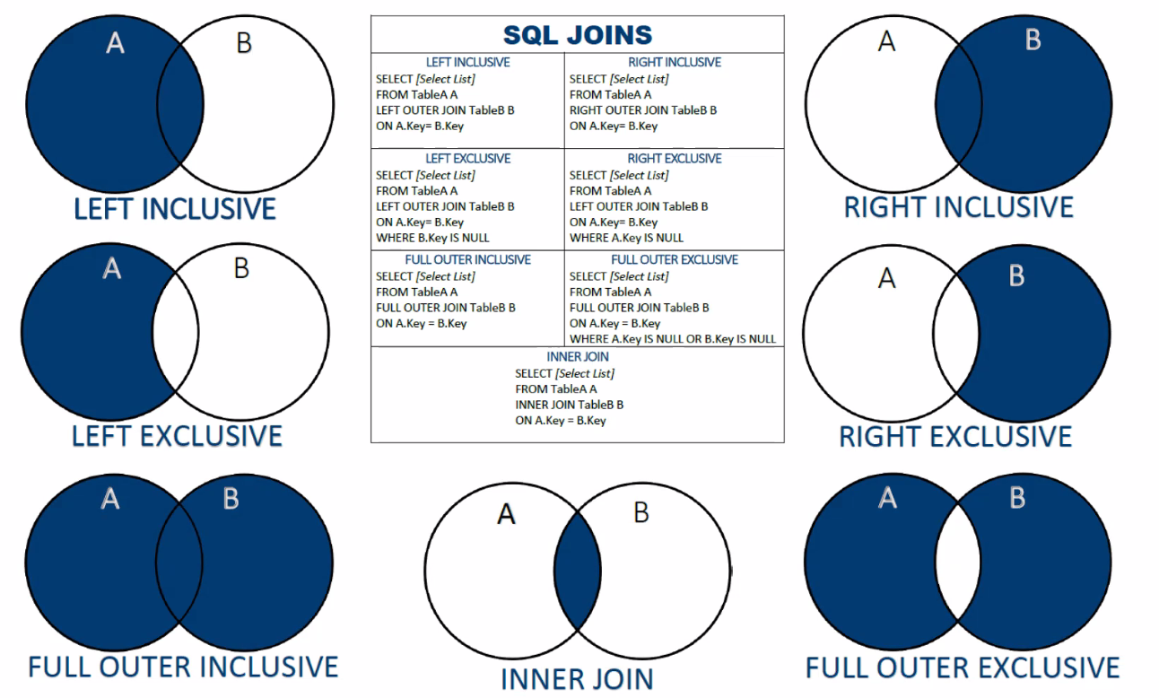

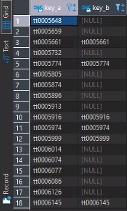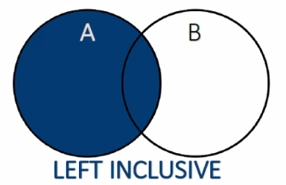

|  |
| --- |
| select a.tconst key_a , b.tconst key_b  from imdb.public.title_basic a  left outer join imdb.public.title_ratings b  on a.tconst = b.tconst; |

* Key A has all the values of tconst from title_basic
* Key B has only values if title_basic.tconst = title_ratings.tconst

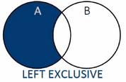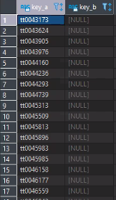

|  |
| --- |
| select a.tconst key_a , b.tconst key_b  from imdb.public.title_basic a  left outer join imdb.public.title_ratings b  on a.tconst = b.tconst  where b.tconst is null  ; |

* All the values in A that are not in B; values that are *exclusive* to A

This is equivalent to the following logic:

|  |
| --- |
| select a.tconst key_a,  from imdb.public.title_basic a  where a.tconst not in (select tconst key_b from imdb.public.title_ratings b); |

But from a performance standpoint the *join* is better than the *in* clause.

|  |
| --- |
| select a.tconst key_a,  from imdb.public.title_basic a  where a.tconst != 'tt0000014' or a.tconst != 'tt0000020'...; |

The cardinality of b.tconst is going to be the number of *or* statements that needs to be executed.

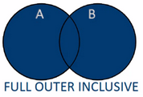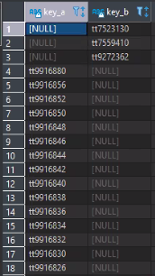

|  |
| --- |
| select a.tconst key_a , b.tconst key_b  from imdb.public.title_basic a  full outer join imdb.public.title_ratings b  on a.tconst = b.tconst  order by key_a desc  ; |

- Obtaining all values from both tables, whether they are exclusive to either table or shared within both.

- Obtaining all values from table B even if it is not in table A.

As you can see, there are three values in table B that are not in table A so a primary key cannot be established.

- For a good foreign key/primary key candidate, every value of the child (*Table B*) should exist in the parent (*Table A*).

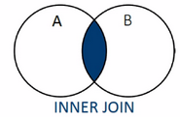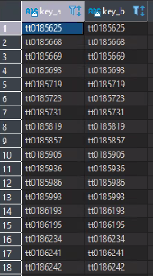

|  |
| --- |
| select a.tconst key_a , b.tconst key_b  from imdb.public.title_basic a  inner join imdb.public.title_ratings b  on a.tconst = b.tconst; |

|  |
| --- |
| SELECT *  FROM imdb.public.title_ratings tr  WHERE tconst LIKE 'tt7523130'; |

- Selects all values from both tables as long as there is a match between the columns.

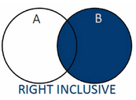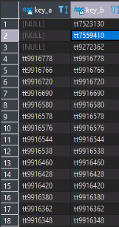

|  |
| --- |
| select a.tconst key_a , b.tconst key_b  from imdb.public.title_basic a  right outer join imdb.public.title_ratings b  on a.tconst = b.tconst  order by key_a desc; |

- Reverse of *Left Inclusive.*

- Obtains all values from table B and all values that are in A as well.

Lecture 09

04/08/2021

Cross Join:

|  |
| --- |
| select tb.tconst, tr.tconst from  imdb.public.title_basic tb  cross join imdb.public.title_ratings tr |

- The two keys tconst in title_basics and tille_ratings are going to be compared

- Each tuple in title_basics is going to be repeated or paired with each and every tuple in title_ratings. You are going to be blowing up the space.

- When you want to create a time series product, a cross product will be useful.

- There are 7,619,417 tuples in title_basics and 1,123,371 tuples in title_ratings. The cross product of the two tables will give … tuples.

Self Join:

|  |
| --- |
| select * from  imdb.public.title_basic tb_a  left join imdb.public.title_basic tb_b on tb_a.tconst = tb_b.tconst; |

Both queries produce the same output

|  |
| --- |
| select tb_a.*,tb_b.* from  imdb.public.title_basic tb_a  left join imdb.public.title_basic tb_b on tb_a.tconst = tb_b.tconst; |

- You join the table to itself that is why it is a self join.

- To do a self join, you take a table and do some kind of join (could be left, inner, right, etc.) and join it to itself on the same key.

- The number of columns this table will have is double of the number of columns in title_basics since we have select * in the example.

|  |
| --- |
| select tb_a.tconst as tconst_a, tb_a.originaltitle as originaltitle_a, tb_a.runtimeminutes as runtimeminutes_a,  tb_b.tconst as tconst_b, tb_b.runtimeminutes as runtimeminutes_b, tb_b.originaltitle as originaltitle_b from  imdb.public.title_basic tb_a  left join imdb.public.title_basic tb_b on cast(tb_a.runtimeminutes as integer)  < cast(tb_b.runtimeminutes as integer)  where tb_a.tconst ='tt0009143'  ; |

- This query uses the nested join algorithm because we are using the less than (<) operation.

- We are joining on tb_a.runtimeminutes, where it needs to be less than tb_b.runtimeminutes. This means that we are finding a specific movie’s runtime (because of the where clause), where it is less compared to other movies’ runtime.

**Problem**: For any combination of two runtime of movies give all the movies where the runtime is less than or equal to 100.

Solution 1:

|  |
| --- |
| with cte_cartesian as (  select  tb_a.tconst as tconst_a,  tb_a.originaltitle as originaltitle_a,  tb_a.runtimeminutes as runtimeminutes_a,  tb_b.tconst as tconst_b,  tb_b.runtimeminutes as runtimeminutes_b,  tb_b.originaltitle as originaltitle_b  from  imdb.public.title_basic tb_a, --cross join  imdb.public.title_basic tb_b  ), cte_cartesian_sum as (  select *, cast(runtimeminutes_b as integer) + cast(runtimeminutes_a as integer) as combined_runtime from cte_cartesian  ), cte_solution as (  select * from cte_cartesian_sum  where combined_runtime<=100  ) select distinct * from cte_solution; |

- Steps:

1. You need to create a combination of all movie runtime. This will be a cartesian self join. (equivalent to a cross join)
2. You need to create another join, where you have to join the tile_basics table to the cartesian table and carry out the comparison.

- There will be repetition in the result if you do not include distinct to the final table result (cte_solution).

Solution 2:

|  |
| --- |
| select distinct  tb_a.tconst as tconst_a,  tb_a.originaltitle as originaltitle_a,  tb_a.runtimeminutes as runtimeminutes_a,  tb_b.tconst as tconst_b,  tb_b.runtimeminutes as runtimeminutes_b,  tb_b.originaltitle as originaltitle_b,  cast(tb_b.runtimeminutes as integer) + cast(tb_a.runtimeminutes as integer) as combined_results  from  imdb.public.title_basic tb_a  left join imdb.public.title_basic tb_b on cast(tb_b.runtimeminutes as integer) + cast(tb_a.runtimeminutes as integer) <=100  where tb_b.runtimeminutes is not null or tb_a.runtimeminutes is not null; |

- This query does not omit null values, so you need to add a where clause to eliminate those case.

Analysis:

* The two solutions differ in comparison. So, in solution 2 the comparison happens in the join clause, where in one step you add the two values together and carry out the comparison and it only brings a value if the join comparison is satisfied. In the first solution, you create the combination independent, and then compare if the two movies will give you a sum of runtime less than or equal to 100 and you filter at the end.
* Both solutions take a long time to execute.

Recursive Join:

* You can reference inside the CTE by a recursive join

**Problem**: Who is the CEO? (aka who doesn't report to anybody?)

Created Table for this problem

|  |
| --- |
| CREATE TABLE Table1  ("ID1" text, "ID2" text)  ;    INSERT INTO Table1  ("ID1", "ID2")  VALUES  ('vc1', 'vc2'),  ('vc2', 'vc3'),  ('vc3', 'vc4'),  ('vc4', 'rc7')  ; |

Solution:

|  |
| --- |
| WITH RECURSIVE chain(from_id, to_id) AS (  SELECT NULL, 'vc2'  UNION  SELECT c.to_id, t."ID2"  FROM chain c  LEFT OUTER JOIN Table1 t ON (t."ID1" = to_id)  WHERE c.to_id IS NOT NULL  )  SELECT from_id FROM chain WHERE to_id IS NULL; |

- ‘vc2’ can be any value, this is the anchor in this problem to help you start off with the recursion.

Output:

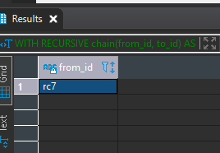

- This value has no body in the hierarchy to report to

One-to-one Relationship:

|  |
| --- |
| select count(distinct tb.tconst) as dst_cnt_tb_tconst,  count(tb.tconst) as cnt_tb_tconst,  count (distinct tr.tconst) as dst_cnt_tr_tconst,  count (tr.tconst) as cnt_tr_tconst  from imdb.public.title_basic tb  inner join imdb.public.title_ratings tr on tb.tconst = tr.tconst |

- When we only have one value for each table for the attribute key that is considered one-to-one relationship.

- To see if two tables have a one-to-one relationship, you do an inner join on the two tables. If the distinct count and the count in tb.tconst has the same value and the distinct count and the count in tr.tconst, then it is a one-to-one relationship.

- You could also do a full outer join, and if it is the same as the inner join output that is considered good as well, and shows a one-to-one relationship.

Lecture 10

04/15/2021

* AND takes both sides of the operator and both sides must be the same to be true.
  + If both values are null, then it will return null.
  + If one of the values is either true/false and the other null, then it will return null.

*AND is bias towards false

* OR evaluates both sides and returns the UNION.
  + If both values are true, then it returns true. The same works for false.
  + If one of the values is true and the other false/null, then it returns true.
  + If both sides of the operator are null, then it returns null.

*OR is bias towards true

* NOT returns the opposite of a condition. Think of multiplying by -1.

*mirror image

|  |
| --- |
| create table employee (emp_id integer, emp_name varchar, on_call boolean);  create table facility (emp_id integer, facility_name varchar );  insert into employee  select 1, 'John', true  union  select 2, 'Bob', false  union  select 3, 'Ed', false  union  select 4, 'Stu', true  insert into facility  select 1, 'warehouse'  union  select 2, 'office'  union  select 3, 'office'  union  select 4, 'store' |

- Create two tables: employee and facility

- Insert values in both tables

|  |
| --- |
| select  e.emp_name as name,  f.facility_name as facility_name,  e.on_call as on_call,  from  employee e,  facility f  where  e.emp_id = f.emp_id -- predicate a  and  f.facility_name in('warehouse','office') -- predicate b    --a and b |

- Predicate a is being used as an equal operator. We are trying to make sure that they have the same values.

|  |
| --- |
| select  e.emp_name as name,  f.facility_name as facility_name,  e.on_call as on_call,  from  employee e  left join facility f on e.emp_id = f.emp_id |

- Left join would return every value in the employee table and facility values that are true

|  |
| --- |
| select  e.emp_name as name,  f.facility_name as facility_name,  e.on_call as on_call,  from  employee e, facility f  where  e.emp_id = f.emp_id -- predicate a  and  f.facility_name ='warehouse' -- predicate b  or f.facility_name ='office' -- predicate c |

- Predicate a is using an equal operator for e.em_id and f.emp_id

- Predicate b is using an equal operator to check the facility name values is equal to ‘warehouse’

- Predicate c is using an equal operator to check the facility name values is equal to ‘office’

|  |
| --- |
| select  e.emp_name as name,  f.facility_name as facility_name,  e.on_call as on_call  from  employee e, facility f  where  e.emp_id = f.emp_id -- predicate a  and  f.facility_name ='warehouse' -- predicate b |



- If the id in the employee table is the same as the id in the facility table, then the name of the employee in the warehouse will be in the output.

-John’s id matches in both tables and predicate b is true

|  |
| --- |
| select  e.emp_name as name,  f.facility_name as facility_name,  e.on_call as on_call  from  employee e inner join facility f  on  e.emp_id = f.emp_id  where  on_call = true -- predicate a  and f.facility_name ='warehouse' -- predicate b  or f.facility_name ='office' -- predicate c |

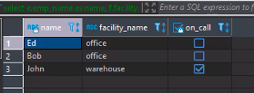

- Where clause with AND and OR with no parenthesis

- It will output all the values that complies with the facility names (warehouse, office) but it outputs all the on_call values as well.

- We want the on_call values that are true

|  |
| --- |
| select  e.emp_name as name,  f.facility_name as facility_name,  e.on_call as on_call  from  employee e inner join facility f  on  e.emp_id = f.emp_id  where  on_call = true -- predicate a  and (f.facility_name ='warehouse' -- predicate b  or f.facility_name ='office') -- predicate c |

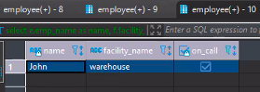

A AND (B OR C)

- We want the facility name for warehouse or facility name for office.

-With parenthesis, it will output one the value that is true (that complies with predicate a)

|  |
| --- |
| select  e.emp_name as name,  f.facility_name as facility_name,  e.on_call as on_call  from  employee e inner join facility f  on  e.emp_id = f.emp_id  where  on_call = true -- predicate a  and f.facility_name ='warehouse' -- predicate b  or f.facility_name ='office' -- predicate c |

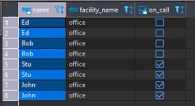

- Inner join would return matching values in both tables.

- Since there is no parenthesis in the where clause, it outputted all the on_call

|  |
| --- |
| select  e.emp_name as name,  f.facility_name as facility_name,  e.on_call as on_call  from  employee e inner join facility f  on  e.emp_id = f.emp_id  where  on_call = true -- predicate a  and (f.facility_name ='warehouse' -- predicate b  or f.facility_name ='office') -- predicate c |

- In this block of code, because there is the presence of parenthesis, then it will return on_call values that are true.

Lecture 10

04/22/2021

HW08 coding interview queries:

|  |
| --- |
| -- Problem 1 (algebra)  select primaryname as "Name", SUM(runtimeminutes) as "Total Runtime" from  xf_title_basic cross join xf_title_principals cross join xf_name_basics where  xf_title_basic.tconst = xf_title_principals.tconst and xf_title_principals.nconst = xf_name_basics.nconst and  primaryname like '%Nicolas%Cage%' and titletype = 'movie'  group by primaryname;  --1 row(s) fetched 41.8s |

|  |
| --- |
| -- Optimised using inner join  select primaryname as "Name", SUM(runtimeminutes) as "Total Runtime" from  xf_title_basic inner join xf_title_principals on  xf_title_basic.tconst = xf_title_principals.tconst inner join  xf_name_basics on xf_title_principals.nconst = xf_name_basics.nconst where  primaryname like '%Nicolas%Cage%' and titletype = 'movie'  group by primaryname;  --1 row(s) fetched 28.7s |

Difference between “IS NULL” and “ = Null”:

|  |
| --- |
| select *  from title_basic nb  where  nb.runtimeminutes=null; |

-- no result because “ = null” is always false.

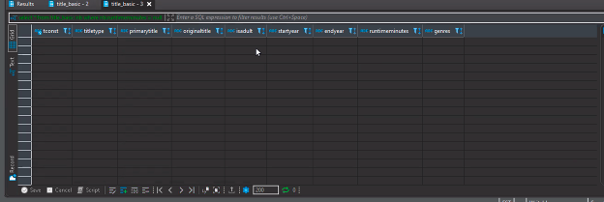

|  |
| --- |
| select *  from title_basic nb  where  nb.runtimeminutes is null; |

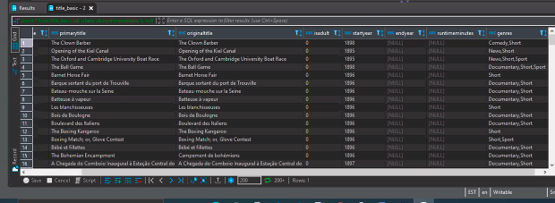

|  |
| --- |
| select null = null; |

Is it a good idea to have NULL as your license plate?

|  |  |  |
| --- | --- | --- |
| License Plate | Date Time | Has E-ZPass |
| ‘ABC 123’ | 2021-04-12 | True |
| NULL |  |  |
| ‘NULL’ |  |  |

Analytical functions:

* Used to

|  |
| --- |
| select  startyear,  avg(runtimeminutes::integer) as runtimeminutes  from  title_basic nb  group by  startyear; |

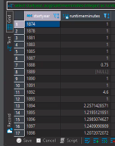

Doing same query as above using window functions:

|  |
| --- |
| select  *,  avg(runtimeminutes::integer) over (partition by startyear) as runtimeminutes  from  title_basic nb; |

* Allows you to calculate the average for every tuple and populate back in table.
* No need to use “group by” clause

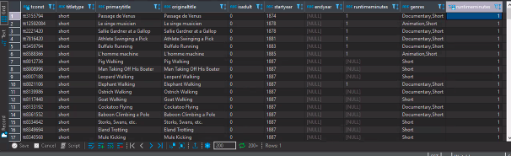

We can modify above query as:

Which movies have runtime that are above the average run time of the year and genres after startyear 2000?

|  |
| --- |
| select  *,  avg(runtimeminutes::integer) over (partition by startyear,  genres) as runtimeminutes,  case  when avg(runtimeminutes::integer) over (partition by startyear, genres)<runtimeminutes::integer then true  else false  end as is_over_average  from  title_basic nb  where  startyear >= '2000' ; |

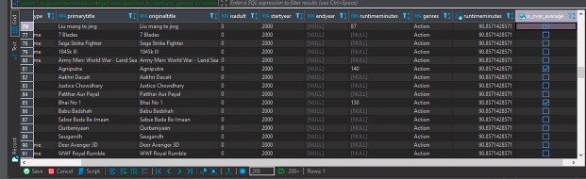

Q. Which movies have runtime that are above average runtime per year and genres?

Step 1: without CTE, have a query grouping by startyear and genre.

Filter the data first to make it smaller.

|  |
| --- |
| select  startyear, genres, avg(runtimeminutes::integer) as avg_runtimeminutes  from title_basic nb  where startyear::integer>=2000  group by  startyear, genres; |

Step 2: Do inner join above query with cte on startyear and genres

|  |
| --- |
| with cte_group_avg as (  select  startyear,  genres,  avg(runtimeminutes::integer) as avg_runtimeminutes  from  title_basic nb  where  startyear::integer >= 2000  group by  startyear,  genres )  select  nb.*,  cga.avg_runtimeminutes  from  title_basic nb  inner join cte_group_avg cga on  nb.startyear = cga.startyear  and nb.genres = cga.genres; |

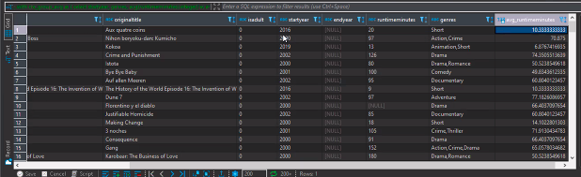

Window Function rank():

-- Give numerical rank to every run time based on its length

|  |
| --- |
| select  *,  rank() over (order by runtimeminutes::integer) as rank_runtimeminutes  from  title_basic nb  where  startyear::integer >= 2000; |

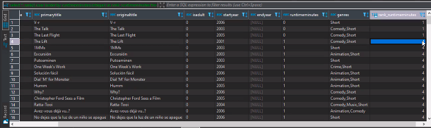

* The rows that have the same values will receive the same **rank**.
* Next rank will not be next number. There will be a gap.
* Use dense_rank() to have no gaps within ranks.

|  |
| --- |
| select  *,  dense_rank() over (order by runtimeminutes::integer) as rank_runtimeminutes  from  title_basic nb  where  startyear::integer >= 2000; |

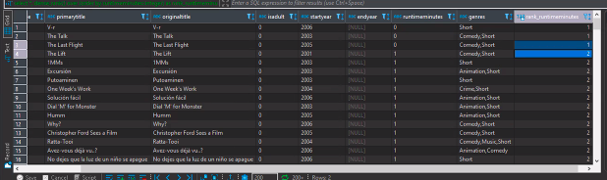

Use partition by genres to start the counter of rank within the genre.

|  |
| --- |
| select  *,  dense_rank() over (partition by genres order by runtimeminutes::integer) as rank_runtimeminutes  from  title_basic nb  where  startyear::integer >= 2000; |

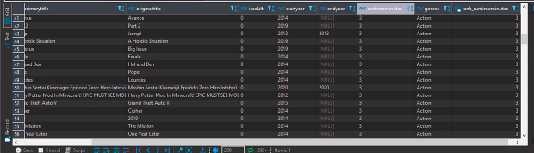

Lead() operator:

Inputs: A column and a offset

Offset is the number of rows you want to forward.

|  |
| --- |
| select  *,  lead(runtimeminutes, 1) over (order by runtimeminutes::integer) as LEAD_runtimeminutes  from  title_basic nb  where  startyear::integer >= 2000; |

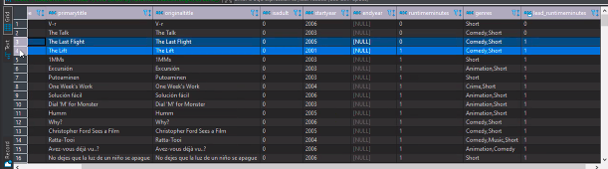

Use partition by to reset the counter:

|  |
| --- |
| select  *,  lead(runtimeminutes, 1) over (partition by genres order by runtimeminutes::integer) as LEAD_runtimeminutes  from  title_basic nb  where  startyear::integer >= 2000; |

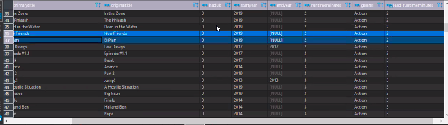

AWS:

* RDS: Relational Data Service. Allows you create a new database. Pick any (PostgreSql preferred). Fill out Database id, password, pick db instance(small and free).
* VPC: Virtual Private Cloud. Equivalent to local network. To access your database from a local machine make sure your local machine has access to VPC Before creating a db make sure to create a VPC. Refer to class lecture recording for how to create a VPC.
* EC2: Elastic Compute Cloud. Equivalent to machine on the cloud (Computing machine).
* S3:

1. Also, if there is an error with the format of one of the strings, the error won’t be thrown.
2. I found this very useful.
3. Don’t you dare quote Prof. Zombory on this as good practice in your application.